Live Collaboration Platform: Build Plan
Oct 6, 2026 · @baljeet

1. Overview
This is a Notion-meets-VS-Code workspace: teams edit pages, write and run code, and chat in the same live project, with no merge conflicts. Build it as a TypeScript monorepo with a Next.js frontend and a separate realtime server.
Core features
- Live collaborative pages (Notion-style blocks): many people edit the same page at once; edits merge automatically using a CRDT (Yjs).
- Collaborative code editor with execution: shared cursors and selections, any language, a Run button that executes code in an isolated sandbox and streams the output to everyone.
- Project chat: real-time messages for everyone who joined the project, saved in the database.
Supporting features the MVP needs
- Sign-up and login, projects (rooms), invite links, and roles (owner, editor, viewer).
- A sidebar tree of pages and code files per project.
- Presence: who is online, and their coloured cursors.
Out of scope for v1: voice/video, comments and version history, mobile apps, AI assistant. These are listed as stretch goals in the build phases.

2. Architecture
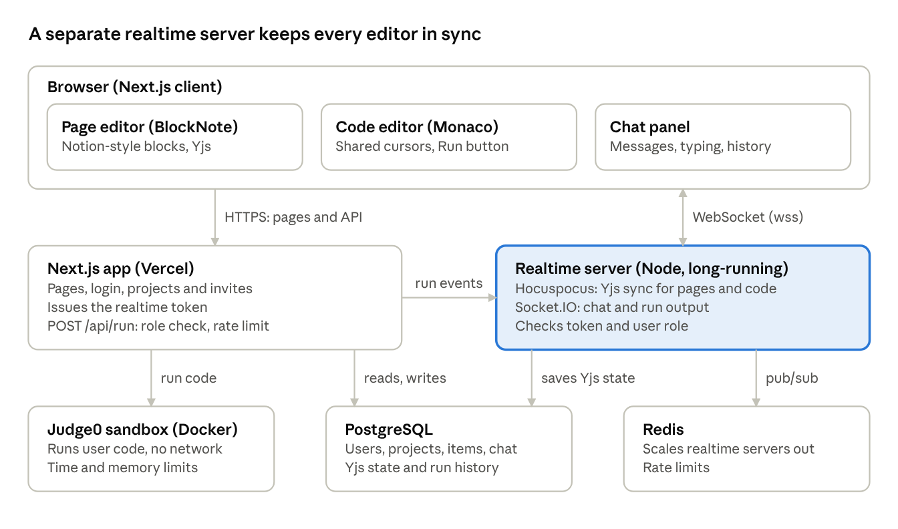
system architecture · 3 app tiers, 3 backing services
Browsers load pages from Next.js and keep one websocket open to the realtime server for live edits and chat. Only the Next.js app talks to the code sandbox, so users can never reach it directly.

3. Tech stack
Use this stack: Next.js for the app, Yjs for conflict-free sync, a small Node server for websockets, and a sandboxed runner for code. Versions drift quickly, so tell your AI to use the latest stable release of each and check the official docs.
Layer | Recommended | Why | Alternative
Framework | Next.js (App Router) + TypeScript | Your requirement; server components, route handlers, easy Vercel deploy | none
UI | Tailwind CSS + shadcn/ui | Fast, accessible components | Mantine
Client state / data | Zustand + TanStack Query | Small stores plus cached API calls | SWR
Validation | Zod | One schema for client, server and socket messages | Valibot
Auth | Better Auth (email, Google, GitHub) | Self-hosted, TypeScript-first, works with Next.js | Auth.js, Clerk (fastest to set up)
Database | PostgreSQL (Neon or Supabase) | Relational data plus binary storage of Yjs state | MySQL
ORM | Prisma | Typed queries, easy migrations | Drizzle
Cache / presence | Redis (Upstash) | Rate limits, cross-server pub/sub | none at first
Conflict-free sync | Yjs (CRDT) | Mature; powers most open-source collaborative editors | Automerge, Loro
Realtime server | Hocuspocus (Node, websockets) | Yjs backend with auth, persistence and Redis hooks built in | y-websocket, PartyKit, Liveblocks (managed, least code)
Notion-style editor | BlockNote | Block UI, slash menu, drag handles, Yjs support out of the box | Tiptap (more control, more work)
Code editor | Monaco Editor + y-monaco | VS Code engine, IntelliSense for many languages | CodeMirror 6 + y-codemirror.next (lighter, better on mobile)
Code execution | Judge0 CE (self-hosted, Docker) | 60+ languages, resource limits, REST API | Piston (self-hosted), E2B sandboxes
Chat transport | Socket.IO on the realtime server | Rooms, reconnect and acknowledgements built in | Ably, Pusher, Supabase Realtime
Monorepo | pnpm + Turborepo | Shares types between web and realtime server | Nx
Testing | Vitest + Playwright | Unit tests plus two-browser collaboration tests | Jest
Hosting | Vercel (web), Railway or Fly.io (realtime, Judge0), Neon (DB) | Vercel cannot hold long-lived websockets | AWS / one VPS with Docker Compose
Fastest path: if you want the smallest build, replace Hocuspocus and Socket.IO with Liveblocks and you skip running the realtime server. The trade-off is vendor lock-in and a bill at scale. The plan below assumes self-hosting, since it teaches more and costs less.

4. Key decisions
Three choices decide whether this project works or becomes a bug farm.
1. Use a CRDT (Yjs), not "last write wins". Each editor (page or code file) is one shared Yjs document. Every keystroke becomes a small update that merges in any order on every client, so two people typing at once never conflict, and offline edits merge on reconnect. Your server only relays and stores updates; it does not decide who wins.
2. Run a separate realtime server. Next.js on Vercel is serverless and cannot hold websocket connections. Build apps/realtime as a long-running Node process that hosts Hocuspocus (Yjs sync) and Socket.IO (chat, run output). The Next.js app issues a short-lived signed token; the realtime server verifies it before allowing a connection.
3. Never run user code on your own servers. Execution goes to a sandbox service (Judge0 or Piston) in Docker, with no network access, CPU and memory limits, and a time limit. The Next.js app calls it only through an authenticated API route, and results are broadcast to the room.
Smaller rules
- Store the Yjs document as binary in Postgres (debounced saves), and keep titles, tree structure and permissions as normal columns.
- Use Yjs awareness for cursors and presence; it needs no database.
- Persist chat messages and run history in Postgres; broadcast them over Socket.IO.
- Enforce roles on the server: a viewer connects read-only, and the realtime server drops their write updates.
- Validate every payload with Zod, shared from packages/shared.

5. Data model
Eight tables cover the whole MVP. A project is the room; everything else hangs off it.
Table | Key columns | Notes
User | id, name, email, image, createdAt | Managed by the auth library
Project | id, name, ownerId, inviteCode, createdAt | The shared room
ProjectMember | projectId, userId, role (OWNER, EDITOR, VIEWER) | Checked on every connection and API call
Item | id, projectId, parentId, type (PAGE, CODE, FOLDER), title, language, order, yjsState (bytes) | Sidebar tree; yjsState holds the Yjs document; language only for CODE
ChatMessage | id, projectId, userId, body, createdAt | Index on (projectId, createdAt)
Run | id, itemId, userId, language, stdin, stdout, stderr, exitCode, durationMs, createdAt | History of code executions
Invite | id, projectId, code, role, expiresAt | Join by link
Session / Account | managed by the auth library | Do not hand-write
Room names used by the realtime server
- Yjs documents: item:<itemId> (one per page or code file)
- Chat and run output: project:<projectId>

6. Folder structure
One pnpm + Turborepo monorepo, so the web app and the realtime server share types and validation.
collab-platform/
├── apps/
│ ├── web/ # Next.js (App Router)
│ │ ├── app/
│ │ │ ├── (auth)/login, signup
│ │ │ ├── (app)/projects/[projectId]/
│ │ │ │ ├── layout.tsx # sidebar tree + chat panel
│ │ │ │ └── [itemId]/page.tsx # renders page editor or code editor
│ │ │ └── api/
│ │ │ ├── auth/[...all]/route.ts
│ │ │ ├── realtime-token/route.ts
│ │ │ └── run/route.ts # calls the sandbox
│ │ ├── components/
│ │ │ ├── editor/ # BlockNote wrapper
│ │ │ ├── code/ # Monaco wrapper, run panel
│ │ │ ├── chat/
│ │ │ └── presence/
│ │ └── lib/ # auth, realtime client, utils
│ └── realtime/ # Node server (long-running)
│ └── src/
│ ├── hocuspocus.ts # Yjs sync + auth + persistence
│ ├── chat.ts # Socket.IO chat handlers
│ └── index.ts
├── packages/
│ ├── db/ # Prisma schema + client
│ ├── shared/ # Zod schemas, types, role helpers
│ └── config/ # tsconfig, eslint
├── infra/
│ └── docker-compose.yml # postgres, redis, judge0 for local dev
├── turbo.json
└── pnpm-workspace.yaml

7. Build phases
Give your AI one phase at a time. Do not move on until every acceptance check passes. Each phase builds on the last.

Phase 0: Setup
Goal: a running monorepo with the database.
- Create the pnpm + Turborepo monorepo with apps/web, apps/realtime, packages/db, packages/shared, packages/config.
- Scaffold Next.js (App Router, TypeScript, Tailwind) and install shadcn/ui.
- Add infra/docker-compose.yml with Postgres and Redis.
- Add the Prisma schema from section 5 and run the first migration.
- Add .env.example, ESLint, Prettier, and a root pnpm dev that starts web and realtime together.
Done when: pnpm dev starts both apps, and Prisma Studio shows all tables.

Phase 1: Auth, projects and roles
Goal: users can sign in, create projects and invite others.
- Set up Better Auth with email/password plus Google and GitHub.
- Protect (app) routes with middleware.
- Build the project list, create-project dialog, and the project layout (sidebar left, content centre, chat right).
- Implement invite links that join a user to a project with a role.
- Add server helper requireRole(projectId, minRole) and use it in every API route and server action.
Done when: two accounts can create a project, one invites the other by link, and a viewer cannot call write endpoints.

Phase 2: Realtime server and persistence
Goal: a Yjs document syncs between browsers and survives restarts.
- Build apps/realtime with Hocuspocus.
- Add /api/realtime-token: returns a short-lived signed JWT containing userId, projectId and role.
- In Hocuspocus onAuthenticate, verify the token and set the connection read-only for viewers.
- Implement onLoadDocument and onStoreDocument (debounced) to read and write Item.yjsState.
- Build a throwaway test page with a plain textarea bound to a Yjs Y.Text to prove sync.
Done when: two browsers see each other's typing live, a refresh keeps the text, and a viewer's edits are rejected.

Phase 3: Notion-style pages
Goal: a page tree with a rich block editor.
- Build the sidebar tree: create, rename, nest, reorder and delete Items of type PAGE and FOLDER (normal database writes; refresh other users with a Socket.IO tree:changed event).
- Integrate BlockNote with its Yjs collaboration option, bound to item:<itemId>.
- Support headings, lists, to-dos, code blocks, images (upload to S3-compatible storage), tables, and the / slash menu.
- Show an online-users avatar stack at the top of the page.
Done when: three browsers edit the same page at once with no lost text, and the page tree updates for everyone without refresh.

Phase 4: Presence and cursors
Goal: see who is where.
- Use Yjs awareness to publish name, colour and cursor or selection.
- Render coloured remote cursors with name labels in both editors.
- Show a project-wide online list in the sidebar, and which item each person is viewing.
Done when: remote cursors move smoothly and disappear within a few seconds of a tab closing.

Phase 5: Collaborative code editor
Goal: shared coding in any language.
- Integrate Monaco (@monaco-editor/react) with y-monaco, bound to item:<itemId>.
- Add a language picker stored on the Item and synced to everyone; Monaco handles syntax highlighting.
- Add a theme toggle, font size, and a stdin input box.
- Load Monaco lazily (next/dynamic, ssr: false) to keep the bundle small.
Done when: two people type in the same file with live cursors, and changing the language updates for both.

Phase 6: Code execution
Goal: a Run button that executes code safely and shows output to everyone.
- Run Judge0 CE in Docker (add to docker-compose.yml) and map the editor's languages to Judge0 language IDs.
- Add POST /api/run: checks role (EDITOR or above), rate-limits per user with Redis, sends code and stdin to Judge0 with time and memory limits, and saves a Run row.
- Broadcast run:started and run:finished over Socket.IO so every collaborator sees the output panel update.
- Build the output panel: stdout, stderr (red), exit code, runtime, and run history.
Done when: Python, JavaScript, C++ and Java run correctly, an infinite loop is killed by the time limit, and all collaborators see the same output.

Phase 7: Chat
Goal: project chat with history.
- Add Socket.IO to apps/realtime; authenticate with the same signed token and join room project:<projectId>.
- Handle chat:send (validate with Zod, save to ChatMessage, broadcast) and load the last 50 messages with cursor pagination.
- Add typing indicators, unread badge, and message grouping by user and time.
- Optional: @mentions, emoji reactions, and a link to the item a user is viewing.
Done when: a user who joins late sees history, messages arrive in under a second, and a viewer can read but not send, if you choose that rule.

Phase 8: Hardening and polish
Goal: ready for real users.
- Add rate limits to chat, run and invite endpoints.
- Sanitize rendered content and enforce file-size limits on uploads.
- Handle reconnects: show a banner while offline and re-sync when back.
- Write Playwright tests with two browser contexts: concurrent typing, role enforcement, chat delivery.
- Add error tracking (Sentry) and structured logs.
Done when: the two-browser tests pass in CI and a network drop mid-edit loses no text.

Phase 9: Deploy
- Deploy apps/web to Vercel, apps/realtime and Judge0 to Railway, Fly.io or a VPS, and the database to Neon.
- Put the realtime server behind TLS (wss://) and set matching CORS and environment variables.
- For more than one realtime instance, enable the Hocuspocus Redis extension so instances share updates.
Done when: two people on different networks can collaborate on the live URL.

Stretch goals (after v1)
- Version history and restore points (Yjs snapshots)
- Inline comments and @mentions on pages
- Multi-file code projects with a file tree, plus a terminal
- Voice and video rooms (LiveKit)
- AI assistant that explains or fixes selected code
- Export a page to Markdown or PDF

8. Master prompt for your AI
Paste this at the start of the session, then add the document sections and send one phase at a time ("Do Phase 2 now").
You are a senior full-stack engineer building a real-time collaborative
platform. I will give you a plan with numbered phases. Build ONE phase at
a time, in order, and stop when the phase's "Done when" checks pass.
Product: projects (rooms) where users co-edit Notion-style pages, co-edit
and run code in any language, and chat live. Conflict-free editing is a
hard requirement.
Fixed stack (use the latest stable versions; check official docs, do not
rely on memory for APIs):
- Monorepo: pnpm + Turborepo, TypeScript strict everywhere
- apps/web: Next.js App Router, Tailwind, shadcn/ui, Zustand, TanStack Query
- apps/realtime: long-running Node server with Hocuspocus (Yjs) and Socket.IO
- packages/db: Prisma + PostgreSQL; packages/shared: Zod schemas and types
- Auth: Better Auth; Cache: Redis
- Page editor: BlockNote with Yjs; Code editor: Monaco with y-monaco
- Code execution: self-hosted Judge0 CE in Docker, called only from the server
Rules:
1. Before coding, list the files you will create or change and why.
2. Never run user code in the Next.js or realtime process.
3. Check the user's role on the server for every API route, socket event
and Yjs connection. Never trust the client.
4. Validate every input with Zod schemas from packages/shared.
5. Do not add libraries outside the stack without asking me first.
6. Keep components small; no "any"; handle loading, error and offline states.
7. After coding, give me exact commands to run it and a manual test
checklist for the phase's "Done when" criteria.
8. If something in the plan is unclear or a library API has changed,
say so and propose a fix instead of guessing.
9. Do not start the next phase until I say so.
Tip: after each phase, commit to Git. If the AI breaks something later, you can roll back to the last working phase.

9. Security and risks
Code execution is the one feature that can seriously hurt you; treat it as hostile input from day one.
Risk | What goes wrong | Mitigation
Malicious code | Crypto mining, attacks on your servers, data theft | Run only in Judge0 or Piston containers with no network, CPU, memory and time limits, and a separate host from your database
Unauthenticated websockets | Anyone joins a room and reads or edits | Short-lived signed token verified in onAuthenticate; check role and project on every connection
Viewers editing | A read-only user sends Yjs updates | Set Hocuspocus connection to read-only for viewers
Abuse and cost | Run spam, chat flooding | Redis rate limits per user and per project; cap run frequency and output size
Data loss | Server crash before a save | Debounced persistence every few seconds, plus a save on last disconnect; take periodic backups of Postgres
Large documents | Yjs history grows and slows loading | Cap page size; compact stored state; consider snapshots later
Scaling websockets | One server hits its connection limit | Add the Hocuspocus Redis extension and run several instances behind a load balancer
XSS in chat and pages | Injected scripts run in other users' browsers | Render chat as text, sanitise any HTML or Markdown, set a strict Content Security Policy

